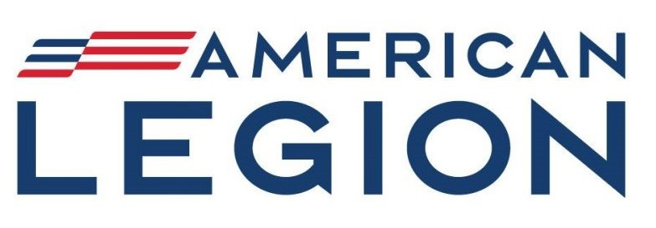
ECKLEY E. PATCH
POST 470, BATH PA.

HOMETOWN HEROS BANNER PROGRAM

American Legion, Eckley E. Patch Post 470 will be running a Hometown Heros Banner Program. The Banners will be 30” x 50” and be double sided printed vinyl.

Cost per banner will be $180.00. Cash or check only. No Digital payments accepted.
Make checks payable to: American Legion Post 470. Place Hometown Heros in memo.

Must provide a picture for the banner. Pictures may be sent digitally or hard copies sent to the Legion Post. Hard copies of pictures will be returned.

Contact:
Program Coordinator – Brian Radcliffe 610-751-6201
Bdradcliffe1973@gmail.com
Commanderpost470@gmail.com

Honoree Profile: (PLEASE PRINT OR TYPE CLEARLY)

Rank: _________________________ First Name: ______________________________

Last Name: __________________________________________________________________

Branch of Service: (Please Highlight or Circle)
US ARMY US MARINE CORPS US NAVY
US AIR FORCE US SPACE FORCE US COAST GUARD
US ARMY NATIONAL GUARD US ARMY AIR NATIONAL GUARD
US MERCHANT MARINES

Service Era: (Please Highlight or Circle)
Civil War (1861 – 1865) Spanish American War (1898) World War I (1917 – 1918)
World War II (1941 – 1945) Korean War (1950 – 1955) Vietnam War (1962 – 1975)
Cold War (1945 – 1991) Persian Gulf War (1991 – 1991)
Global War on Terrorism (2001 – Present) Non-Combat Service

Address or location you would like the banner placed: BATH MOORE TOWNSHIP

____________________________________________________________
____________________________________________________________
If no location is listed, banner will be placed as available.

Circle if you’d like to add the following:
KIA POW MIA List other: ____________________________________

Medals:
Medal of Honor Purple Heart Sliver Star Bronze Star

Other: ________________________________________________________

Please Provide:

Name of Sponsor / Purchaser (will be printed on bottom of banner)

______________________________________________________________

Address: ______________________________________________________

______________________________________________________

Phone Number: ________________________________________________

Email Address: _________________________________________________

(Address is needed to return pictures)

Thank you for participating in our Hometown Heros Banner Program. Please email the application and picture to either of the above email address. Or mail the to:

American Legion Post 470
HOMETOWN HEROES CAMPAIGN
278 Race Street
Bath, Pa. 18014

